Assignment -1

MAKE SMART HOME WITH ATLEAST 2 SENSORS AND LED BUZZER IN THINKERCAD

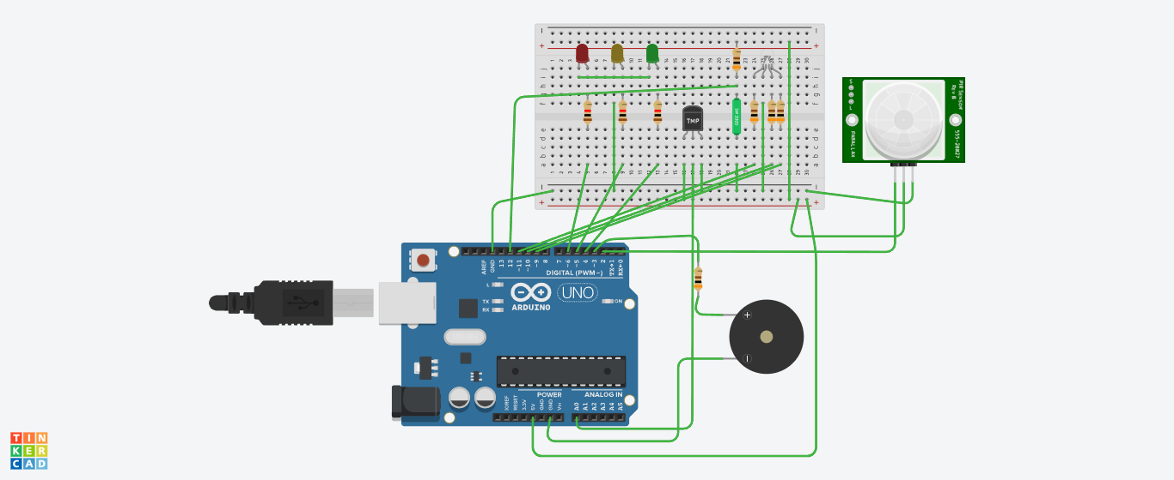

SCHEMATIC:

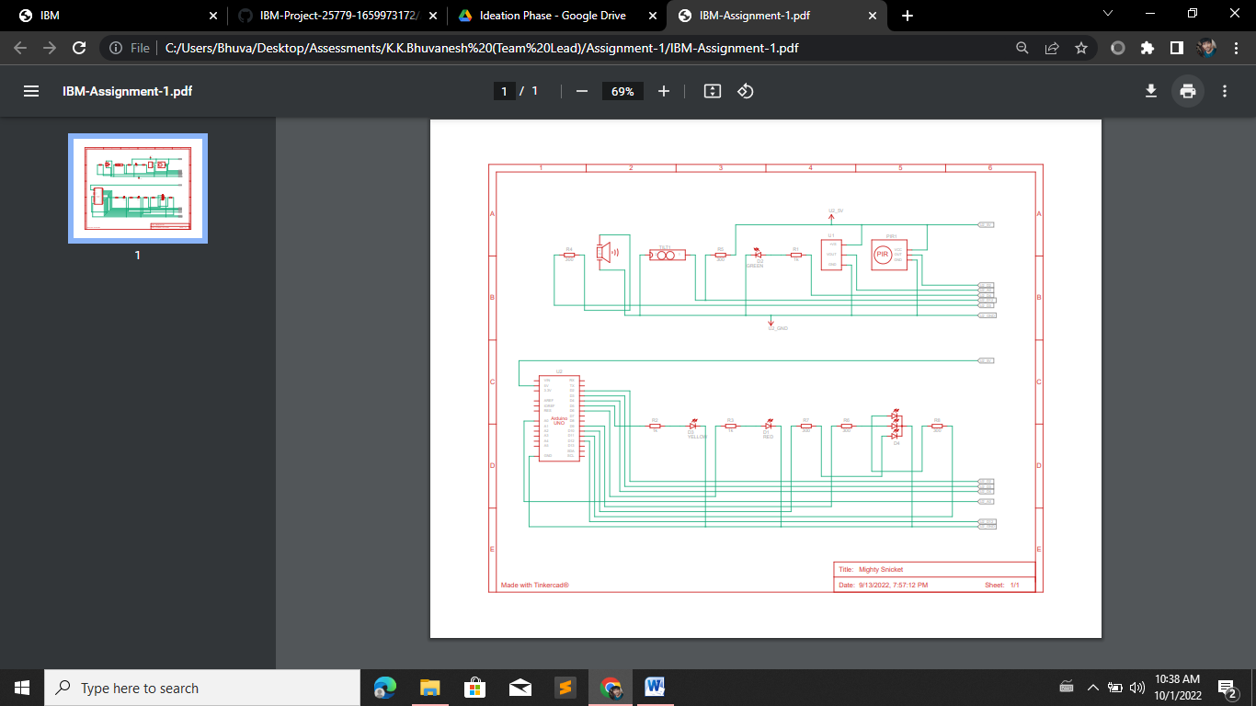

CODE (ARDUINO) :

const int led1=6,led2=5,led3=4;

const int pir=2,tilt=12,buzzer=3,r=11,g=10,b=9;

const int temp=A0;

int carry,i,j,k;

void setup()

{

pinMode(led1,OUTPUT);

pinMode(led2,OUTPUT);

pinMode(led3,OUTPUT);

pinMode(buzzer,OUTPUT);

pinMode(pir,INPUT);

pinMode(tilt,INPUT);

pinMode(r,OUTPUT);

pinMode(g,OUTPUT);

pinMode(b,OUTPUT);

Serial.begin(9600);

}

void loop()

{

carry=digitalRead(tilt);

i=digitalRead(pir);

j=analogRead(temp);

delay(500);

if((carry==1)&&(i!=HIGH))

{

digitalWrite(led1,HIGH);

delay(500);

digitalWrite(led2,HIGH);

delay(500);

digitalWrite(led3,HIGH);

delay(500);

digitalWrite(led1,LOW);

delay(500);

digitalWrite(led2,LOW);

delay(500);

digitalWrite(led3,LOW);

delay(500);

}

else if(i!=HIGH)

{

digitalWrite(led3,HIGH);

delay(500);

digitalWrite(led2,HIGH);

delay(500);

digitalWrite(led1,HIGH);

delay(500);

digitalWrite(led3,LOW);

delay(500);

digitalWrite(led2,LOW);

delay(500);

digitalWrite(led1,LOW);

delay(500);

}

if(i==HIGH)

{

digitalWrite(led1,HIGH);

digitalWrite(led2,HIGH);

digitalWrite(led3,HIGH);

tone(buzzer,1200,500);

digitalWrite(led1,LOW);

digitalWrite(led2,LOW);

digitalWrite(led3,LOW);

}

if(j<100)

{

analogWrite(r,255);

analogWrite(g,0);

analogWrite(b,0);

delay(100);

analogWrite(r,0);

analogWrite(g,255);

analogWrite(b,0);

delay(100);

analogWrite(r,0);

analogWrite(g,0);

analogWrite(b,255);

delay(100);

analogWrite(r,255);

analogWrite(g,0);

analogWrite(b,255);

delay(100);

analogWrite(r,255);

analogWrite(g,255);

analogWrite(b,0);

delay(100);

analogWrite(r,0);

analogWrite(g,255);

analogWrite(b,255);

delay(100);

analogWrite(r,255);

analogWrite(g,255);

analogWrite(b,255);

}else{

analogWrite(r,0);

analogWrite(g,0);

analogWrite(b,0);

}

}: